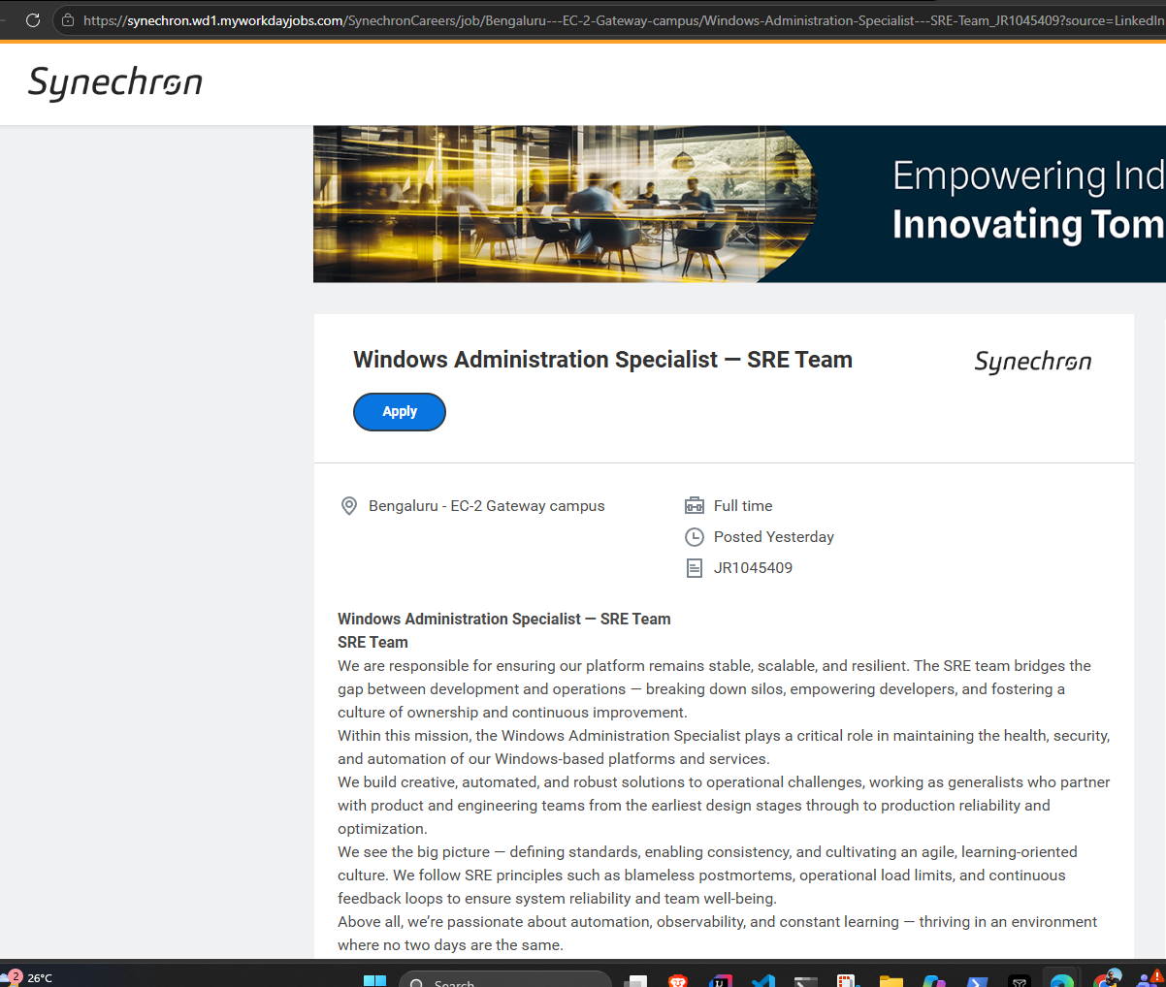

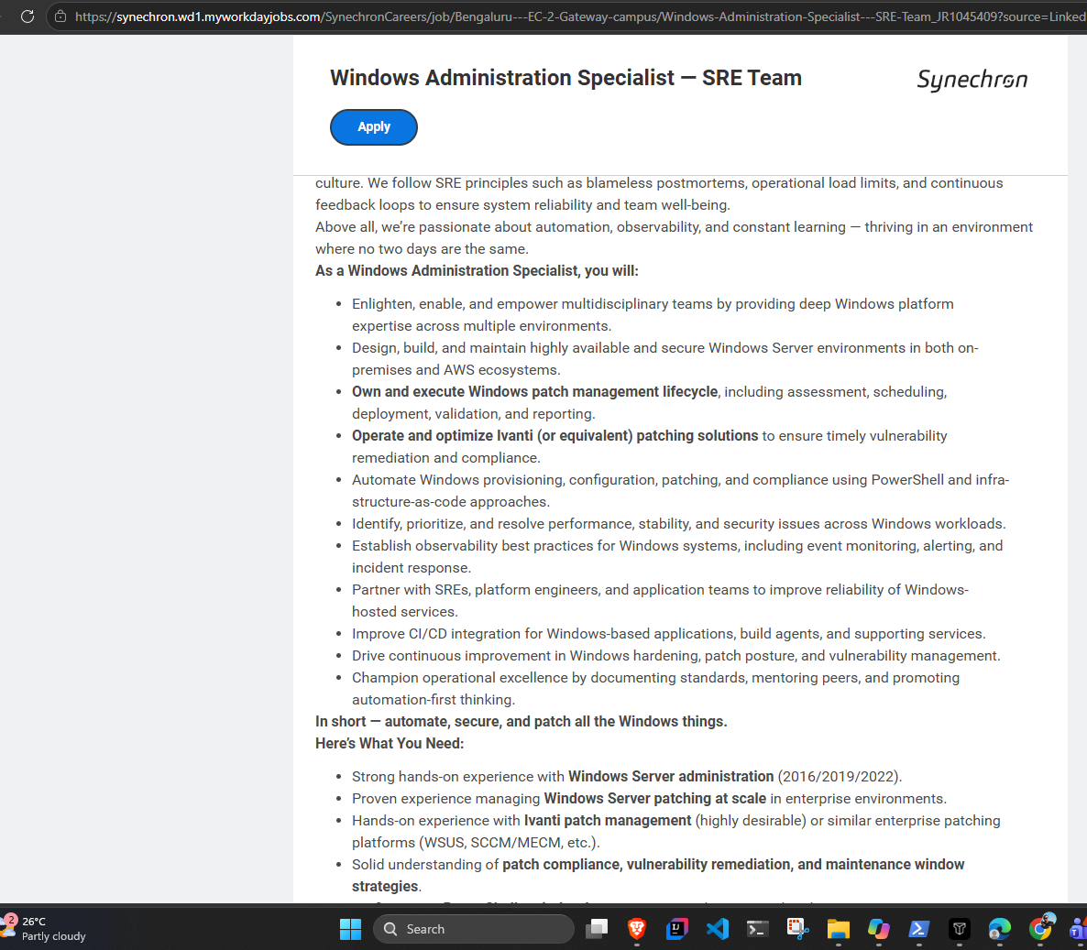

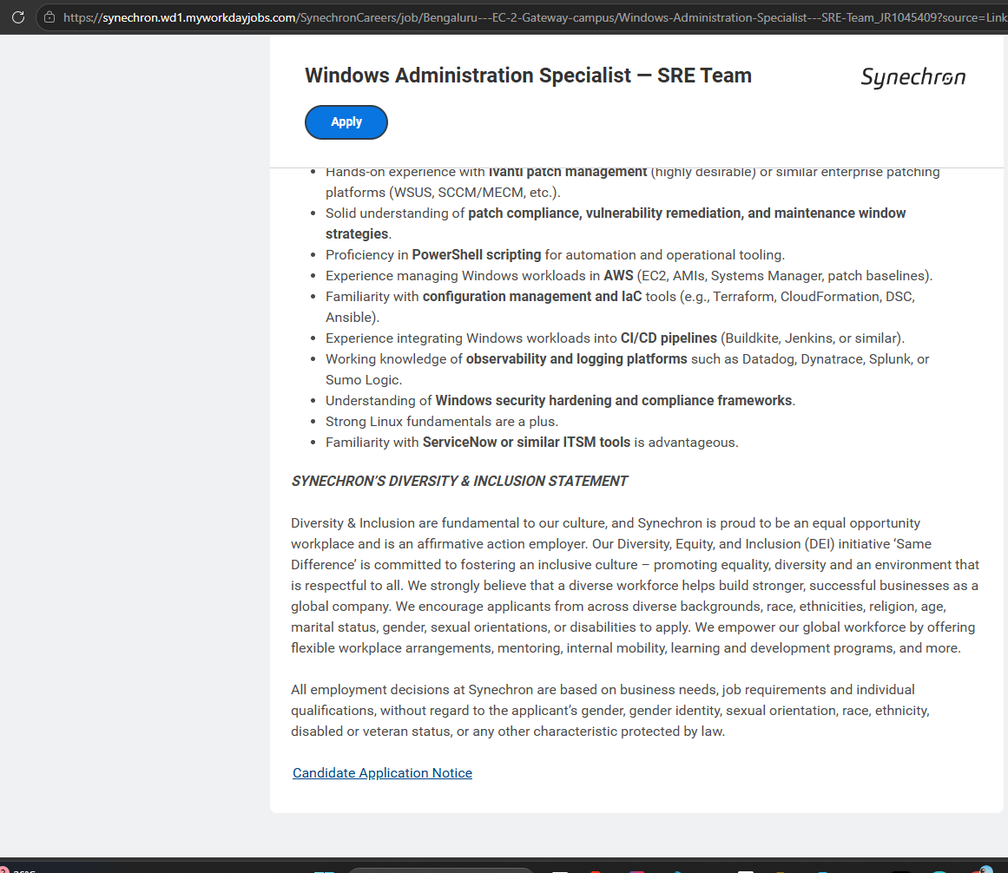

Bengaluru - EC-2 Gateway campus
time type
Full time
posted on
Posted Yesterday
job requisition id
JR1045409
Windows Administration Specialist — SRE Team
SRE Team
We are responsible for ensuring our platform remains stable, scalable, and resilient. The SRE team bridges the gap between development and operations — breaking down silos, empowering developers, and fostering a culture of ownership and continuous improvement.
Within this mission, the Windows Administration Specialist plays a critical role in maintaining the health, security, and automation of our Windows-based platforms and services.
We build creative, automated, and robust solutions to operational challenges, working as generalists who partner with product and engineering teams from the earliest design stages through to production reliability and optimization.
We see the big picture — defining standards, enabling consistency, and cultivating an agile, learning-oriented culture. We follow SRE principles such as blameless postmortems, operational load limits, and continuous feedback loops to ensure system reliability and team well-being.
Above all, we’re passionate about automation, observability, and constant learning — thriving in an environment where no two days are the same.
As a Windows Administration Specialist, you will:
- Enlighten, enable, and empower multidisciplinary teams by providing deep Windows platform expertise across multiple environments.
- Design, build, and maintain highly available and secure Windows Server environments in both on-premises and AWS ecosystems.
- Own and execute Windows patch management lifecycle, including assessment, scheduling, deployment, validation, and reporting.
- Operate and optimize Ivanti (or equivalent) patching solutions to ensure timely vulnerability remediation and compliance.
- Automate Windows provisioning, configuration, patching, and compliance using PowerShell and infrastructure-as-code approaches.
- Identify, prioritize, and resolve performance, stability, and security issues across Windows workloads.
- Establish observability best practices for Windows systems, including event monitoring, alerting, and incident response.
- Partner with SREs, platform engineers, and application teams to improve reliability of Windows-hosted services.
- Improve CI/CD integration for Windows-based applications, build agents, and supporting services.
- Drive continuous improvement in Windows hardening, patch posture, and vulnerability management.
- Champion operational excellence by documenting standards, mentoring peers, and promoting automation-first thinking.
In short — automate, secure, and patch all the Windows things.
Here’s What You Need:
- Strong hands-on experience with Windows Server administration (2016/2019/2022).
- Proven experience managing Windows Server patching at scale in enterprise environments.
- Hands-on experience with Ivanti patch management (highly desirable) or similar enterprise patching platforms (WSUS, SCCM/MECM, etc.).
- Solid understanding of patch compliance, vulnerability remediation, and maintenance window strategies.
- Proficiency in PowerShell scripting for automation and operational tooling.
- Experience managing Windows workloads in AWS (EC2, AMIs, Systems Manager, patch baselines).
- Familiarity with configuration management and IaC tools (e.g., Terraform, CloudFormation, DSC, Ansible).
- Experience integrating Windows workloads into CI/CD pipelines (Buildkite, Jenkins, or similar).
- Working knowledge of observability and logging platforms such as Datadog, Dynatrace, Splunk, or Sumo Logic.
- Understanding of Windows security hardening and compliance frameworks.
- Strong Linux fundamentals are a plus.
- Familiarity with ServiceNow or similar ITSM tools is advantageous.
S​YNECHRON’S DIVERSITY & INCLUSION STATEMENT
Diversity & Inclusion are fundamental to our culture, and Synechron is proud to be an equal opportunity workplace and is an affirmative action employer. Our Diversity, Equity, and Inclusion (DEI) initiative ‘Same Difference’ is committed to fostering an inclusive culture – promoting equality, diversity and an environment that is respectful to all. We strongly believe that a diverse workforce helps build stronger, successful businesses as a global company. We encourage applicants from across diverse backgrounds, race, ethnicities, religion, age, marital status, gender, sexual orientations, or disabilities to apply. We empower our global workforce by offering flexible workplace arrangements, mentoring, internal mobility, learning and development programs, and more.
All employment decisions at Synechron are based on business needs, job requirements and individual qualifications, without regard to the applicant’s gender, gender identity, sexual orientation, race, ethnicity, disabled or veteran status, or any other characteristic protected by law.

